**Patient Health Questionnaire- (PHQ)**

Conover Chiropractic

**Patient Name:** **Date:**

1. **Describe your symptoms**

1. *WHEN did your symptoms start?*
2. *HOW did your symptoms start?*
3. *Have you had similar symptoms in the past?* Yes/No
   1. If yes, have you received treatment in the past for the same or similar symptoms, who did you see?
      1. This Office IV. Physical Therapist
      2. Another Chiropractor V. Massage Therapy
      3. Medical Doctor VI. Pain Management Other:
4. **How often do you experience your symptoms? Indicate where you have pain/ symptoms**
   1. 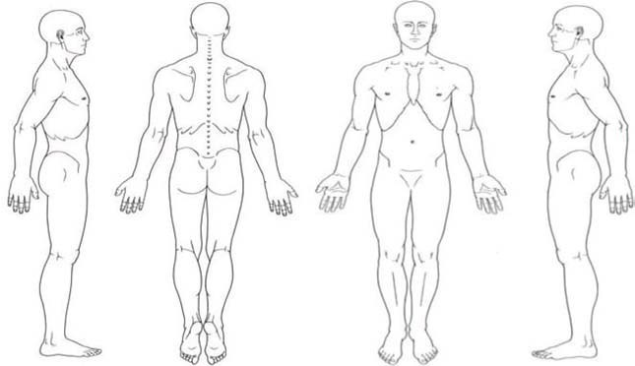Constantly (67-100% of the day)
   2. Frequently (51-75% of the day)
   3. Occasionally (26-50% of the day)
   4. Intermittently (0-25% of the day)
5. **Are your symptoms/condition changing?**
   1. Getting worse
   2. Not changing
   3. Getting better
6. **What describes the nature of your symptoms?**
   1. Sharp (knife) d. Shooting
   2. Dull ache e. Burning
   3. Numb f. Tingling g. Cramping
7. **Do you have numbness or pins/needles/radiating pain in:**
   1. Upper arm R/L d. Buttocks R/L g. Foot R/L
   2. Forearm R/L e. Thigh R/L h. NONE
   3. Hand R/L (FINGERS: 1, 2, 3, 4, 5) f. Calf R/L
8. **Rate your pain on a scale of 1-10? 5a. When is the pain worse?**
   1. Cervical Spine (neck) **a.** Morning b. Afternoon
   2. Thoracic Spine (mid back) **c.** Evening d. All the time
   3. Lumbar Spine (lower back) **e.** Other:
9. **What makes the pain better?**
10. **What makes the pain worse?**